**3. SYSTEM ANALYSIS**

**3.1. INTRODUCTION**

The Systems Development Life Cycle (SDLC), or Software Development Life Cycle in [systems engineering](http://en.wikipedia.org/wiki/Systems_engineering), [information systems](http://en.wikipedia.org/wiki/Information_systems) and [software engineering](http://en.wikipedia.org/wiki/Software_engineering), is the process of creating or altering systems, and the models and [methodologies](http://en.wikipedia.org/wiki/Methodologies) that people use to develop these systems. In software engineering the SDLC concept underpins many kinds of [software development methodologies](http://en.wikipedia.org/wiki/Software_development_methodologies). These methodologies form the framework for planning and controlling the creation of an information system the [software development process](http://en.wikipedia.org/wiki/Software_development_process).

**3.2. EXISTING SYSTEM**

People use cloud storage for the daily demands, for example backing-up data, sharing file to their friends via social networks such as Face book [3], Zing Me [2]. Users also probably upload data from many different types of devices such as computer, mobile phone or tablet. After that, they can download or share them to others. System load in cloud storage is usually really heavy. Thus, to guarantee a good quality of service for users, the system has to face many difficult problems and requirements.

**Disadvantages**

* Storing, retrieving and managing big-files in the system efficiently.
* Parallel and resumable uploading and downloading.
* Data de-duplication to reduce the waste of storage space caused by storing the same static data from different users.

**3.3. PROPOSED SYSTEM**

A common method for solving these problems which is used in many Distributed File Systems and Cloud Storages is splitting big file to multiple smaller chunks, storing them on disks or distributed nodes and then managing them using a meta-data system. Storing chunks and meta-data efficiently and designing a lightweight meta-data are significant problems that cloud storage providers have to face. After a long time of investigating, the current cloud storage services have a complex meta-data system; at least the size of metadata is linear to the file size for every file. Therefore, the space complexity of these meta-data system is O (n) and it is not well scalable for big-file. In this research, Propose new big-file cloud storage architecture and a better solution to reduce the space complexity of meta-data.

**Advantages**

* Propose a light-weight meta-data design for big file. Very file has nearly the same size of meta-data.
* Propose a logical contiguous chunk-id of chunk collection of files. That makes it easier to distribute data and scale-out the storage system.
* Bring the advantages of key-value store into big-file data store which is not default supported for big-value. ZDB is used for supporting sequential write, small memory-index overhead.

**3.4. SOFTWARE DEVELOPMENT LIFE CYCLE**

**3.4.1. Stages In SDLC**

1. Requirement Gathering
2. Analysis
3. Designing
4. Coding
5. Testing
6. Installation & Acceptance Test
7. Maintenance

**3.4.1.1. Requirements Gathering Stage**

The requirements gathering process takes as its input the goals identified in the high-level requirements section of the project plan. Each goal will be refined into a set of one or more requirements. These requirements define the major functions of the intended application, define operational data areas and reference data areas, and define the initial data entities. Major functions include critical processes to be managed, as well as mission critical inputs, outputs and reports. A user class hierarchy is developed and associated with these major functions, data areas, and data entities. Each of these definitions is termed a Requirement. Requirements are identified by unique requirement identifiers and, at minimum, contain a requirement title and textual description.

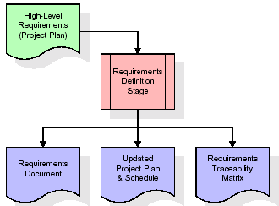

**Figure 3.4.1.1:** Requirements Gathering stage

These requirements are fully described in the primary deliverables for this stage: the Requirements Document and the Requirements Traceability Matrix (RTM). The requirements document contains complete descriptions of each requirement, including diagrams and references to external documents as necessary. Note that detailed listings of database tables and fields are *not* included in the requirements document.

The title of each requirement is also placed into the first version of the RTM, along with the title of each goal from the project plan. The purpose of the RTM is to show that the product components developed during each stage of the software development lifecycle are formally connected to the components developed in prior stages.

In the requirements stage, the RTM consists of a list of high-level requirements, or goals, by title, with a listing of associated requirements for each goal, listed by requirement title. In this hierarchical listing, the RTM shows that each requirement developed during this stage is formally linked to a specific product goal. In this format, each requirement can be traced to a specific product goal, hence the term requirements traceability.

The outputs of the requirements definition stage include the requirements document, the RTM, and an updated project plan.

* Feasibility study is all about identification of problems in a project.
* No. of staff required to handle a project is represented as Team Formation, in this case only modules are individual tasks will be assigned to employees who are working for that project.
* Project Specifications are all about representing of various possible inputs submitting to the server and corresponding outputs along with reports maintained by administrator.

**3.4. 1.2. Analysis Stage**

The planning stage establishes a bird's eye view of the intended software product, and uses this to establish the basic project structure, evaluate feasibility and risks associated with the project, and describe appropriate management and technical approaches.

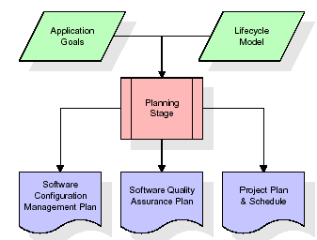

**Figure 3.4.1.2:** Analysis Stage

The most critical section of the project plan is a listing of high-level product requirements, also referred to as goals. All of the software product requirements to be developed during the requirements definition stage flow from one or more of these goals. The minimum information for each goal consists of a title and textual description, although additional information and references to external documents may be included. The outputs of the project planning stage are the configuration management plan, the quality assurance plan, and the project plan and schedule, with a detailed listing of scheduled activities for the upcoming Requirements stage, and high level estimates of effort for the out stages.

**3.4.1.3. Designing Stage**

The design stage takes as its initial input the requirements identified in the approved requirements document. For each requirement, a set of one or more design elements will be produced as a result of interviews, workshops, and/or prototype efforts. Design elements describe the desired software features in detail, and generally include functional hierarchy diagrams, screen layout diagrams, tables of business rules, business process diagrams, pseudo code, and a complete entity-relationship diagram with a full data dictionary. These design elements are intended to describe the software in sufficient detail that skilled programmers may develop the software with minimal additional input.

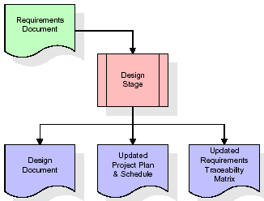

**Figure 3.4.1.3:** Designing Stage

When the design document is finalized and accepted, the RTM is updated to show that each design element is formally associated with a specific requirement. The outputs of the design stage are the design document, an updated RTM, and an updated project plan.

**3.4.1.4. Development (Coding) Stage**

The development stage takes as its primary input the design elements described in the approved design document. For each design element, a set of one or more software artifacts will be produced. Software artifacts include but are not limited to menus, dialogs, data management forms, data reporting formats, and specialized procedures and functions. Appropriate test cases will be developed for each set of functionally related software artifacts, and an online help system will be developed to guide users in their interactions with the software.

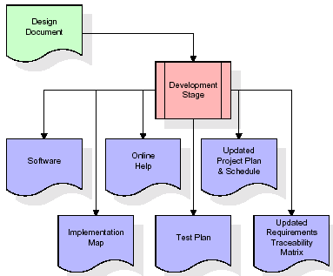

**Figure 3.4.1.4:** Development (Coding) Stage

The RTM will be updated to show that each developed artifact is linked to a specific design element, and that each developed artifact has one or more corresponding test case items. At this point, the RTM is in its final configuration. The outputs of the development stage include a fully functional set of software that satisfies the requirements and design elements previously documented, an online help system that describes the operation of the software, an implementation map that identifies the primary code entry points for all major system functions, a test plan that describes the test cases to be used to validate the correctness and completeness of the software, an updated RTM, and an updated project plan.

**3.4.1.5. Integration & Test Stage**

During the integration and test stage, the software artifacts, online help, and test data are migrated from the development environment to a separate test environment. At this point, all test cases are run to verify the correctness and completeness of the software. Successful execution of the test suite confirms a robust and complete migration capability. During this stage, reference data is finalized for production use and production users are identified and linked to their appropriate roles. The final reference data (or links to reference data source files) and production user list are compiled into the Production Initiation Plan.

The outputs of the integration and test stage include an integrated set of software, an online help system, an implementation map, a production initiation plan that describes reference data and production users, an acceptance plan which contains the final suite of test cases, and an updated project plan.

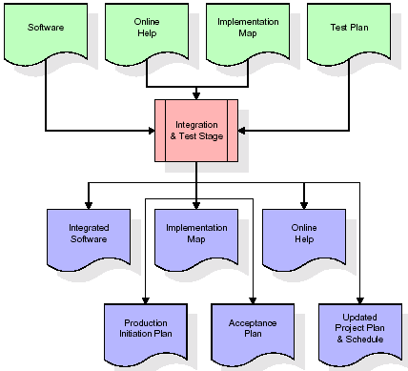

**Figure 3.4.1.5:** Integration & Test Stage

**3.4.1.6. Installation & Acceptance Test**

During the installation and acceptance stage, the software artifacts, online help, and initial production data are loaded onto the production server. At this point, all test cases are run to verify the correctness and completeness of the software. Successful execution of the test suite is a prerequisite to acceptance of the software by the customer.

After customer personnel have verified that the initial production data load is correct and the test suite has been executed with satisfactory results, the customer formally accepts the delivery of the software.

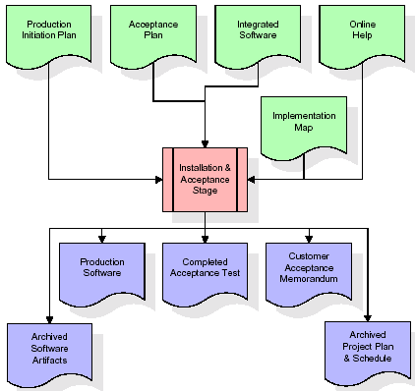

**Figure 3.4.1.6:** Installation & Acceptance Test

The primary outputs of the installation and acceptance stage include a production application, a completed acceptance test suite, and a memorandum of customer acceptance of the software. Finally, the PDR enters the last of the actual labor data into the project schedule and locks the project as a permanent project record. At this point the PDR "locks" the project by archiving all software items, the implementation map, the source code, and the documentation for future reference.

**3.4.1.7. Maintenance**

Outer rectangle represents maintenance of a project, Maintenance team will start with requirement study, understanding of documentation later employees will be assigned work and they will undergo training on that particular assigned category.

For this life cycle there is no end, it will be continued so on like an umbrella (no ending point to umbrella sticks)

**3.4.2. Umbrella Model**

SDLC is nothing but Software Development Life Cycle. It is a standard which is used by software industry to develop good software.

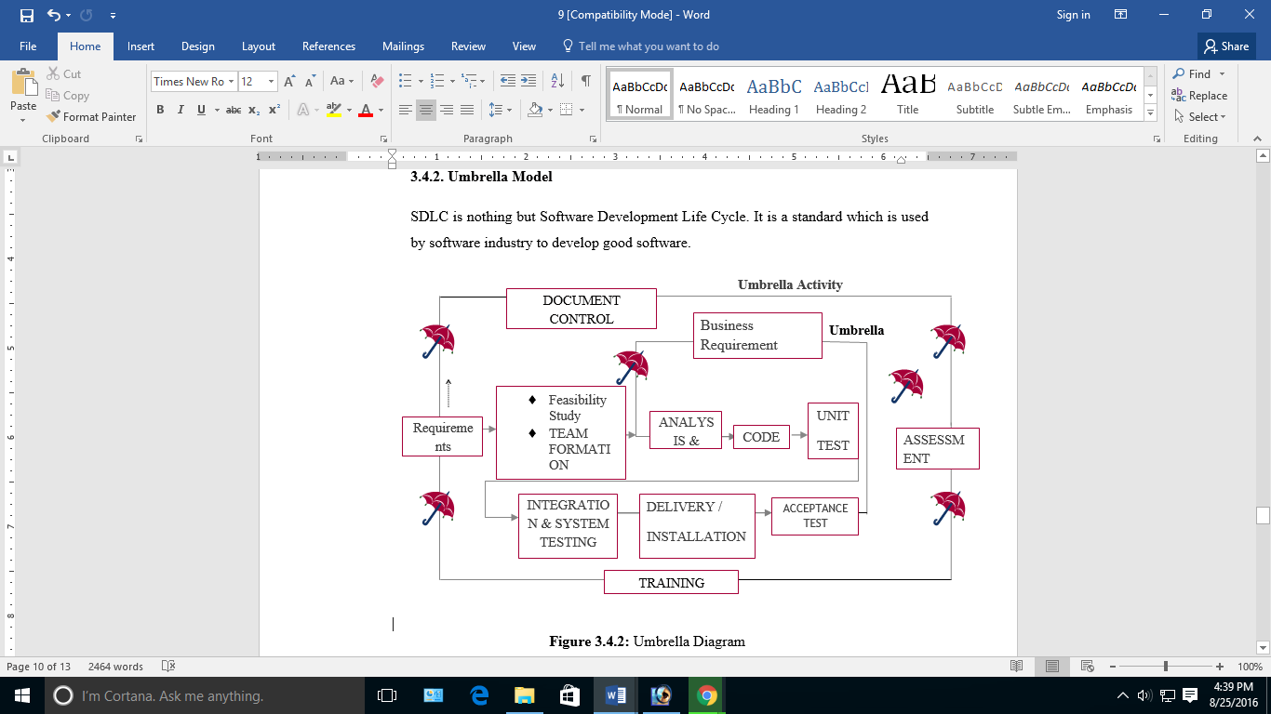

**Figure 3.4.2:** Umbrella Diagram

**3.5. SOFTWARE REQUIREMENT SPECIFICATION**

**3.5.1. Overall Description**

A Software Requirements Specification (SRS) is a [requirements specification](http://en.wikipedia.org/wiki/Requirements_specification) for a [software system](http://en.wikipedia.org/wiki/Software_system) is a complete description of the behavior of a system to be developed. It includes a set of [use cases](http://en.wikipedia.org/wiki/Use_case) that describe all the interactions the users will have with the software. In addition to use cases, the SRS also contains non-functional requirements. [Nonfunctional requirements](http://en.wikipedia.org/wiki/Non-functional_requirements) are requirements which impose constraints on the design or implementation (such as [performance engineering](http://en.wikipedia.org/wiki/Performance_engineering) requirements, [quality](http://en.wikipedia.org/wiki/Quality_%28business%29) standards, or design constraints).

**System Requirements Specification:** A structured collection of information that embodies the requirements of a system. A [business analyst](http://en.wikipedia.org/wiki/Business_analyst), sometimes titled [system analyst](http://en.wikipedia.org/wiki/System_analyst), is responsible for analyzing the business needs of their clients and stakeholders to help identify business problems and propose solutions. Within the [systems development lifecycle](http://en.wikipedia.org/wiki/Systems_development_life_cycle) domain, the BA typically performs a liaison function between the business side of an enterprise and the information technology department or external service providers. Projects are subject to three sorts of requirements:

[**Business Requirements**](http://en.wikipedia.org/wiki/Business_requirements)**:** Describe in business terms what must be delivered or accomplished to provide value.

**Product Requirements:** Describe properties of a system or product (which could be one of several ways to accomplish a set of business requirements.)

**Process Requirements:** Describe activities performed by the developing organization. For instance, process requirements could specify .Preliminary investigation examine project feasibility, the likelihood the system will be useful to the organization. The main objective of the feasibility study is to test the Technical, Operational and Economical feasibility for adding new modules and debugging old running system. All system is feasible if they are unlimited resources and infinite time. There are aspects in the feasibility study portion of the preliminary investigation.

**3.6. FEASIBILITY STUDY**

**3.6.1. Economic Feasibility**

A system can be developed technically and that will be used if installed must still be a good investment for the organization. In the economical feasibility, the development cost in creating the system is evaluated against the ultimate benefit derived from the new systems. Financial benefits must equal or exceed the costs. The system is economically feasible. It does not require any addition hardware or software. Since the interface for this system is developed using the existing resources and technologies available at NIC, There is nominal expenditure and economical feasibility for certain.

**3.6.2. Operational Feasibility**

Proposed projects are beneficial only if they can be turned out into information system. That will meet the organization’s operating requirements. Operational feasibility aspects of the project are to be taken as an important part of the project implementation. This system is targeted to be in accordance with the above-mentioned issues. Beforehand, the management issues and user requirements have been taken into consideration. So there is no question of resistance from the users that can undermine the possible application benefits.

**3.6.3. Technical Feasibility**

Earlier no system existed to cater to the needs of ‘Secure Infrastructure Implementation System’. The current system developed is technically feasible. It is a web based user interface for audit workflow at NIC-CSD. Thus it provides an easy access to .the users. The database’s purpose is to create, establish and maintain a workflow among various entities in order to facilitate all concerned users in their various capacities or roles. Permission to the users would be granted based on the roles specified. Therefore, it provides the technical guarantee of accuracy, reliability and security.

**3.7. SYSTEM REQUIREMENTS & SPECIFICATION**

**3.7.1. External Interface Requirements**

**User Interface:** The user interface of this system is a user friendly Java Graphical User Interface.

**Hardware Interfaces:** The interaction between the user and the console is achieved through Java capabilities.

**Software Interfaces:** The required software is JAVA1.6.

**Operating Environment:** Windows XP, Linux.

* + 1. **Hardware Requirements**
* System : Pentium IV 2.4 GHz
* Hard Disk : 40 GB
* Floppy Drive : 1.44 MB
* Monitor : 15 VGA Colour
* Mouse : Logitech
* RAM : 512 MB

**3.7.3 Software Requirements**

* Operating system : Windows XP/8
* Coding Language : JAVA
* Front end : AWT, Swings
* Database : My-SQL